Beginner Tutorial: Using JupyterLite for Python Practice

# 1. How to Access JupyterLite

Visit the JupyterLite platform provided by your teacher or try https://jupyterlite.readthedocs.io/en/latest/try/lab/

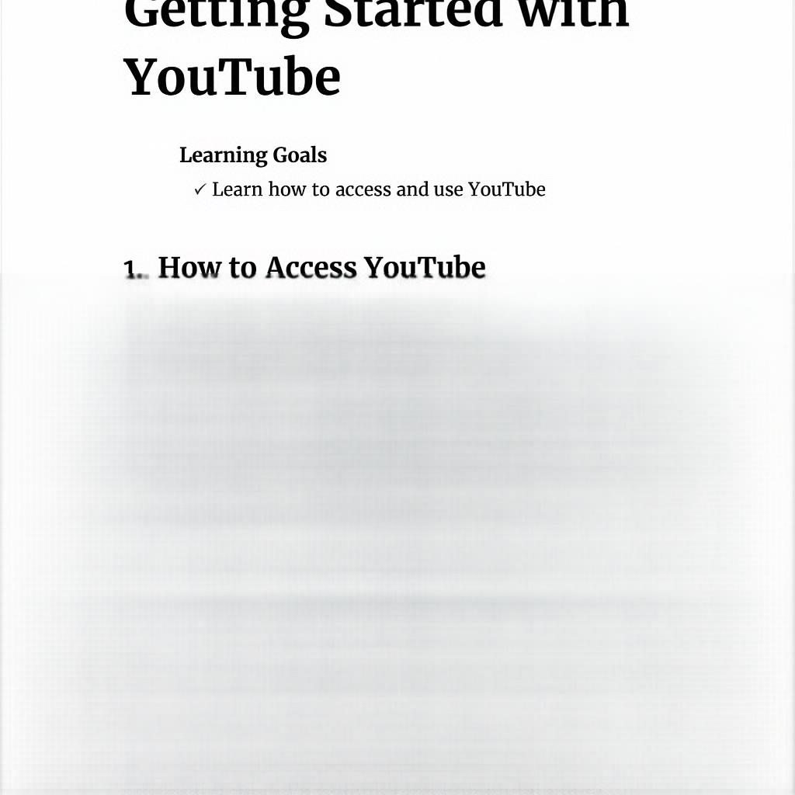

# 2. How to Open a Notebook

Click the folder icon on the left, browse to your notebook (.ipynb file), and double-click to open it.



# 3. How to Save Changes

Click File → Save Notebook or use the save icon to store your work.



# 4. How to Run Code

Select a cell and press Shift+Enter to run the code. Outputs appear directly below the cell.

